ASSIGNMENT 9

Name-Spandan Deb

Topology
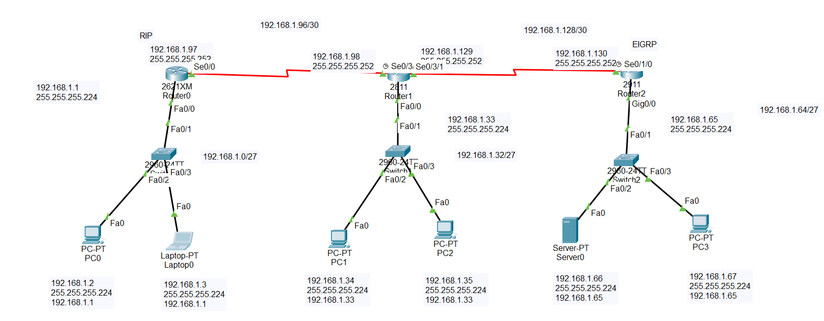

Securing port fa0/2 with max mac-address as 1 and violation as shutdown
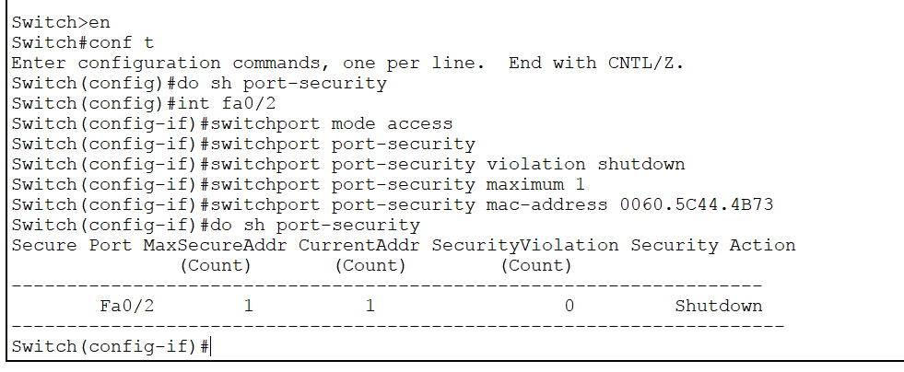

Connected the naughty user with the secured port fa0/2
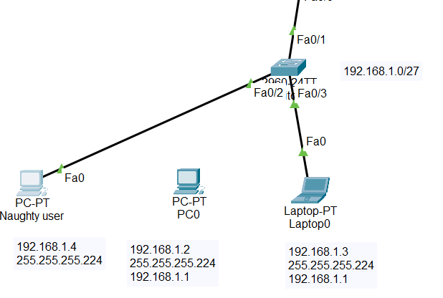
Ping failed and the port link has turned red indicating link is down
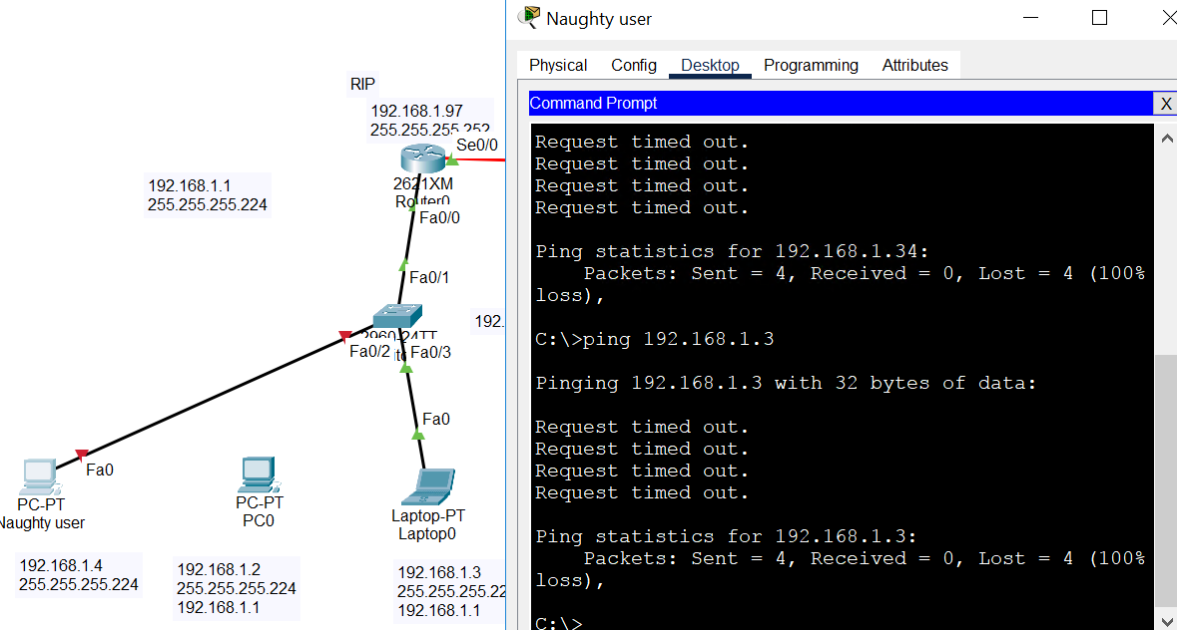

Port security status, Port shut
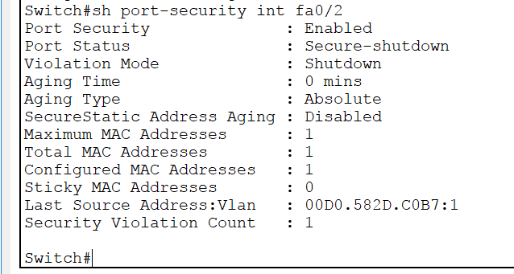

Connected the port to the designated pc and then manually changed the port link to green
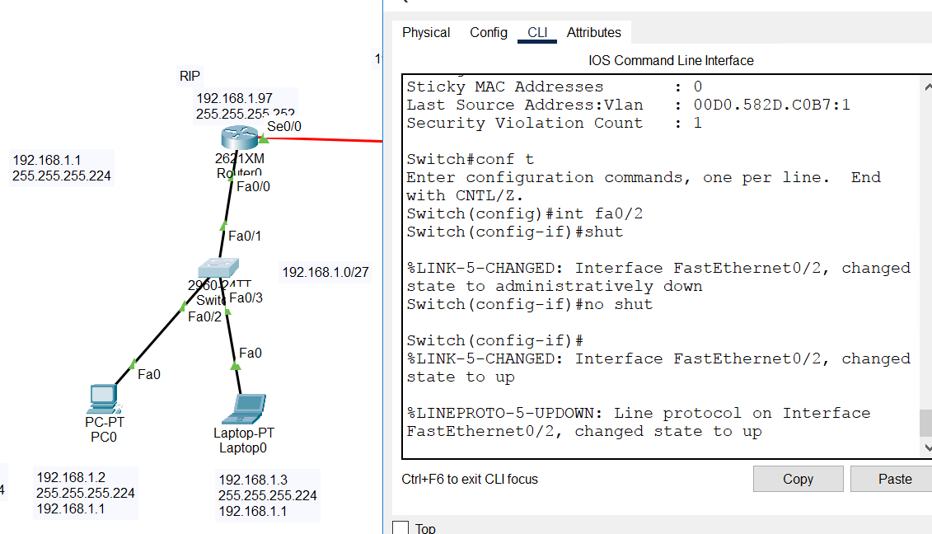

Ping from PC0
